**Computer Networks Lab (CS 353): Lab 10**

Total Marks: 10

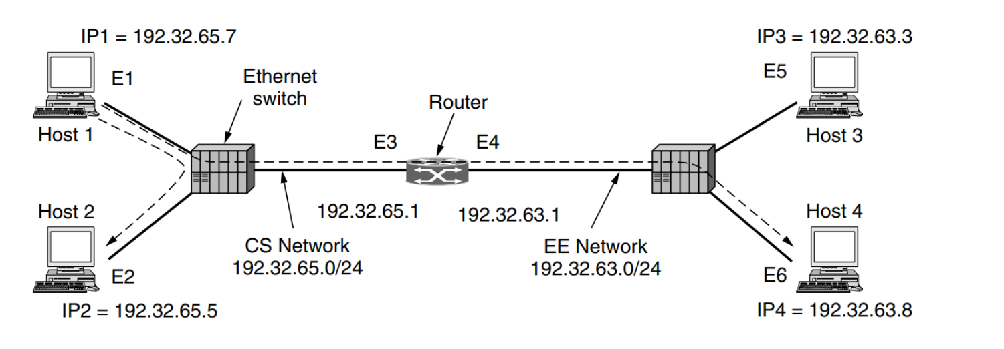

Create a network as shown above to study the working of ARP. Configure an application to send data from Host 1 to Host 2 and another application to send data from Host2 to Host4. Document the ARP table and IP forwarding tables of the switches and routers respectively, for both the cases.